Discussion assignment unit 6
Part 1: Using the terms "equivalent" and "identical" to distinguish between objects and values.
Two lists are said to be equivalent if they have the same elements. However, two lists will not be identical if they are not the same object. It should be noted that identical objects are also equivalent, but equivalent objects are not necessarily identical (Downey, 2015). See example below to note the difference between “equivalent” and “identical.”
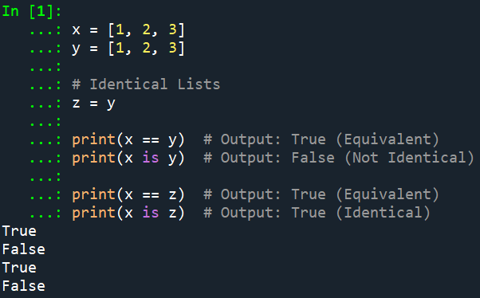
Explanation:
In the example above, x and y ate are equivalent because they share the elements 1, 2, and 3, but they are not identical because of occupying different memory locations. On the other hand, x and z are both equivalent and identical because they are both referring to the same memory location.
Part 2: Creating a function that modifies a list
In Python, objects refer to entities holding different values such as variables, lists, functions. On the other hand, references refer to pointers to objects, allowing us to access and manipulate the object's value, while aliasing occurs when an object with more than one reference has more than one name (Downey, 2015). See example below showing object, reference, and aliasing.
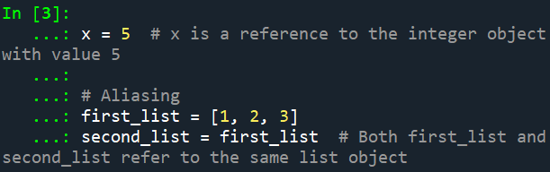
The code block below shows an example of a function modifying a list:
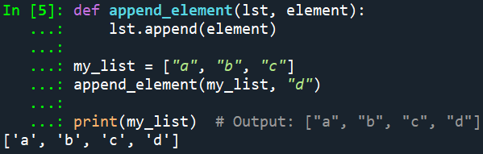
Explanation:
In the example above, the function append_element takes a list (lst) and an element as arguments. It modifies the list by appending the element to it. Since lists are mutable objects, any changes made to the list inside the function will affect the original list passed as an argument.

Reference
Downey, A. (2015). Think Python: How to think like a computer scientist. Green Tree Press.

Identical Objects:

Two objects are identical in Python when they both point to the same memory location. When we assign a list to a variable, we assign the reference of that list to the variable. If two objects are identical, they are also naturally equal too.

fruits = ['apricot', 'pineapple', 'strawberry', 'tangerine', 'pear']

same_fruits = fruits

print(fruits)
output:
['apricot', 'pineapple', 'strawberry', 'tangerine', 'pear']

print(same_fruits)
output:
['apricot', 'pineapple', 'strawberry', 'tangerine', 'pear']

print(fruits is same_fruits)
output:
True

Here we get True when we compare the lists with is operator. is operator compares the identity (memory location) of the lists.

print(f'Id of fruits: {id(fruits)} | Id of same_fruits: {id(same_fruits)}')
output:
Id of fruits: 2532496868352 | Id of same_fruits: 2532496868352

id() function returns an integer which is the identity of the object. The memory address of the lists are the same, hence they are identical.

When we modify the same_fruits, the original fruits list will be modified as well. same_fruits is the alias of the fruits list.

same_fruits[1] = 'banana'

print(fruits)
output:
['apricot', 'banana', 'strawberry', 'tangerine', 'pear']

print(same_fruits)
output:
['apricot', 'banana', 'strawberry', 'tangerine', 'pear']

Equivalent Objects:

Two objects can be equivalent but not identical. For example, when we compare two lists with double equal sign operator (==), we only compare the values of the lists.

animals = ['gopher', 'monkey', 'kangaroo', 'silver fox']

animals_2 = ['gopher', 'monkey', 'kangaroo', 'silver fox']

print(animals == animals_2)
output:
True

print(animals is animals_2)
output:
False

Even though the two lists above have the same values, they are not identical. They are equivalent. Equivalent objects have the same values but refer to different memory locations. The order of elements in the lists does matter when comparing two lists using the double equal sign operator (==).

print(f'Id of animals: {id(animals)} | Id of animals_2: {id(animals_2)}')
output:
Id of animals: 3137537725952 | Id of animals_2: 3137537723456

Notice the memory location of the lists are not the same. They reference two distinct objects in memory. Modifying animals_2 will not have an effect on animals list.

Function:

def my_func(s, n):
index = 0
while index < len(s):
if(len(s[index]) > n):
del s[index]
else:
s[index] = s[index].upper()
index += 1

my_func(animals, 7)
my_func(fruits, 6)

print(animals)
output:
['GOPHER', 'MONKEY']

print(fruits)
output:
['BANANA', 'PEAR']
The my_func function takes two parameters: s and n. The parameter s is the list of strings that will be modified, and n is the maximum length allowed for each string. If the length of the string is more than n, the string will be deleted with the del statement. If the length of the string is less than or equal to n, the string is converted to uppercase.

When we pass animals to the function, we actually are passing a reference to the original list object. The function now has a reference to the same list as the original one in memory. The function modifies the list s in place, which means it directly changes the content of the original list object using the reference passed as an argument.

Python uses pass-by-object-reference, which means that changes made to the object inside the function affect the original object outside the function.

Question:

Modifying the list in place or returning a new list? Which one do you prefer? What are the pros and cons of each method?

Resources:

Python id() (n.d) Programiz.
Pass by Reference in Python: Background and Best Practices (n.d) Real Python

